NAME: ______________________________

Detroit Bikes

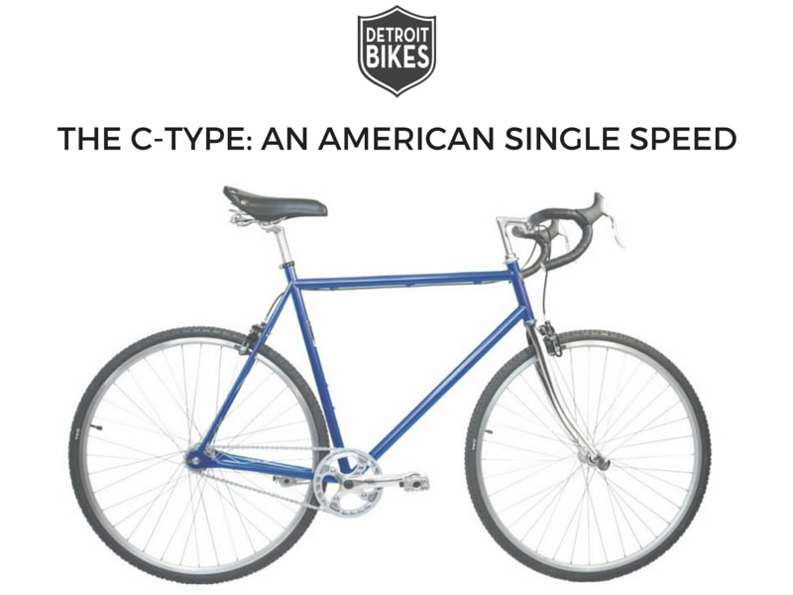

Please save this as a Word file, then provide your answer following each question. In 3 plus pages, double-spaced, please address the following and submit at the beginning of class in hard-copy only and stapled – for up to 5%! Higher grades will reflect depth of analysis and recommendations.

1. Apply the PEST and PORTER e-scan model to the Detroit Bikes business model. Based on this, what is your take on the attractiveness of their industry? Please double check to make sure your name is on your case summary.

2. What is the competitive advantage of Detroit Bikes? Brand? Low-cost? Innovation? Niche? Diversification? Please explain. How would you characterize their target market? Also, how would you characterize the Detroit Bikes brand?

3. What would you suggest is the best strategy to grow the business? Market expansion? Product expansion? Diversification? Please explain. What are the opportunities and risks with this growth strategy?

If you had money to invest, would you invest in their business? Why or why not?

